2.02 + 2.04 + 2.07 + 2.08 = 53% of total score points

2.02 Use trigonometric and inverse trigonometric functions to model and solve problems; justify results.
2.02a Solve using graphs and algebraic properties. (1)
2.02b Create and identify transformations with respect to period, amplitude, and vertical and horizontal shifts. (1)
2.02c Develop and use the law of sines and the law of cosines. (2)
Vocabulary/Concepts/Skills  Period  Amplitude  Phase Shift  Frequency  Intercepts  Sinusoidal  Domain/Range  Law of Sines  Law of Cosines  Dependent Variables  Identities  Trig Ratios (sin, cos, tan, sec, csc, cot)  Effects of a, b, c, and d in $y=af\left(bx+c\right)+d$ | 1. At a particular location on the Atlantic coast, a pier extends over the water. The height of the water on one of the supports is 5.4 feet, at low tide (2 AM) and 11.8 feet at high tide, 6.2 hours later.  a. Write an equation describing the depth of the water at this location t hours after midnight.  b. Use the form $h\left(t\right)=a∙cos\left[\frac{2π}{T}\left(t-b\right)\right]+c$. What will be the depth of the water at this support at 4 AM?
 | 2. Find the amplitude, period and phase shift of the function $f\left(x\right)=-\frac{1}{2}\sin\left(\frac{π}{6}-3x\right)$
 | 3. Solve $2∙sin(0.5x) = 0.75$ for $π ≤ x ≤ 2π$
4. In the interval $[0, 2π)$, find the exact solutions for $sin 2x - tan x = 0$ without
a calculator.

5. To find the distance between two points A and B on opposite sides of a lake,
a surveyor chooses a point C which is 720 feet from A and 190 feet from B. If the angle at C measures $68°$, find the distance from A to B

6. Solve $2\sin^{2}θ-sinθ-3=0 for 0≤θ≤2π$

7. Using the formula, $sin\left(α+β\right)=sinα∙cosβ+cosα∙sinβ$, find $sin⁡\left(\frac{7π}{12}\right)$ without a calculator.

8. Verify the following trigonometric identity. $\frac{cos (x)}{1+sin (x)}=sec\left(x\right)-tan (x)$.

9. A plane is flying from city A to city B, which is 115 mi due north. After flying 45 mi, the pilot must change course and fly 15° west of north to avoid a thunderstorm. If the pilot remains on this course for 25 mi, how far will the plane be from city B?

10. Prove that the following statements are true.
a. $\sin{θ(\cot{θ+\tan{θ)=\sec{θ}}}}$ b. $\sec^{4}{θ-\sec^{2}{θ=\tan^{4}{θ+\tan^{2}{θ}}}}$

c. $\frac{\cos{(α-β)}}{\cos{α\cos{β}}}=1+\tan{α\tan{β}}$ d. $\cos^{4}{θ-\sin^{4}{θ=\cos{(2θ)}}}$

11. Convert to radians.
a. $367°$ b. $-48.5°$ c. $596°$

12. Convert to degrees.
a. $-\frac{5π}{19}$ b. $\frac{62π}{7}$ c. $\frac{3π}{20}$

13. Find one positive coterminal angle and one negative coterminal angle for each of the following.
a. $103°$ b. $\frac{3π}{8}$ c.. $-\frac{14π}{11}$

14. Write the exact value of all six trig ratios for the following angles.
a. $\frac{11π}{6}$ b. $225°$

15. Write the exact value of all six trig ratios using the given information.
a. $\cos{θ=\frac{-3}{5}, θ}$ is in quadrant 3 b. $\sec{θ=4} and\tan{θ<0}$

16. Two trees are 120 feet apart. From the exact middle between them, the angles of elevation of their tops are $18° and 19.5°$. How much taller is one tree than the other?

17. Find all exact solutions for the following equations.
a. $\cos{θ=-\frac{\sqrt{3}}{2}}$ b. $2\sin{θ-1=0}$ c. $3\tan{θ+3=0}$
d. $\cos\left(3θ\right)=\frac{1}{2}$ e. $2sin\left(5θ+\frac{π}{3}\right)+\sqrt{2}=0$

18. Use a calculator to solve each equation on the interval $[0, 2π$).
a. $\sin{θ=-0.89}$ b. $\cos{θ=0.23}$ c. $\tan{θ=-2.15}$

19. Graph two periods of each of the following. Find the transformations, amplitude, period, domain, and range.
a. $y=-2\sin\left(4x+π\right)+1$ b. $y=3\cos{\frac{1}{3}\left(x-\frac{π}{2}\right)-2}$

20. Examine the graph below and determine the amplitude, period, phase shift, and vertical shift of each using COSINE as the parent function for (a) and using SINE as the parent function for (b). Then write an equation of the function.
a. b.
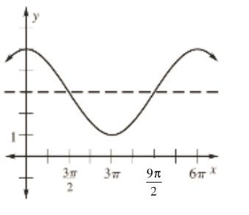
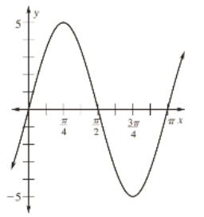
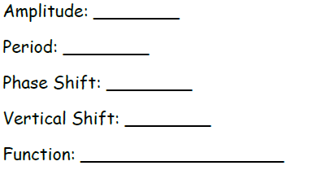

21. Identify the amplitude, period, phase shift and vertical shift of the following trig functions.
a. $y=5-2sin⁡\left(\frac{2x}{3}\right)$ b. $y=3cos⁡(6x+π)$

22. Given the following information about each trig function, write a possible equation for each.
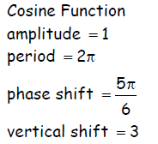
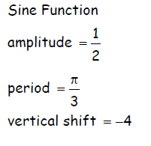
a. b.

2.04 Use the composition and inverse of functions to model and solve problems. (4)
Vocabulary/Skills/Concepts  Decomposition  $$f∘f^{-1}\left(x\right)=x$$  $$f^{-1}(x)∘f=x$$  Reflection over $y=x$  Domain/Range of Inverses  One-to-One  Domain Restrictions | 1 Write the inverse of $f\left(x\right)={(x-2)}^{2}+3$ if $x≤2$.
 | 2. Let $f\left(x\right)=\frac{x}{x-3}$ and $g\left(x\right)=\frac{x+1}{2x}$. Find and simplify $f\left(g\left(x\right)\right)$ and identify its domain.
 | 3. If $f\left(x\right)=-4x+2$ and $g\left(x\right)=\sqrt{x-8}$, when does $\left(f∘g\right)\left(x\right)=-6$?
 | 4. Write the inverse of $y=2^{3x}+4$.
 | 5. Write the inverse of $h\left(x\right)=\sqrt[3]{x}-3$
6. Find the inverse of each of the following.
a. $f\left(x\right)=3x-11$ b. $f\left(x\right)={2x}^{2}+1$

2.07 Use recursively defined functions to model and solve problems.
2.07 a-Find the sum of a finite sequence (1)
2.07 b-Find the sum of an infinite sequence (0)
2.07 c-Determine whether a given series converges or diverges (1)
2.07 d-Translate between recursive and explicit representations (2)
Vocabulary/Concepts/Skills  Linear Sequence  Arithmetic Sequence  Geometric Sequence  Geometric Series  Subscript Notation  Summation Notation  Converge  Diverge  Translate between recursive and explicit representations | 1. A sequence of numbers is defined as $a_{1}=7, a_{2}=\sqrt[3]{a_{1}}+1, a_{3}=\sqrt[3]{a_{2}}+1$ and in general $a_{n+1}=\sqrt[3]{a_{n}}+1$ for all $n≥1$. What is the value of $a_{5}$ to the nearest hundredth?
 | 2. How do you know when a series converges or diverges?
3. Use the following series to answer the questions below: $\sum_{n=4}^{8}{(3n-2)}$
a. Write the series in expanded form.
b. Evaluate the series through the given terms.

 | 4. Find the sum of the first 20 terms of the arithmetic sequence with $a_{12}=63$ and $a_{19}=7$. Write an explicit formula for the sequence
5. James knows that a certain convergent series has the sum of 2.5 and its first term is 2.
Find the “r” value for this series.

6. There are 15 rows of seats on a concert hall with 25 seats in the 1st row, 27 seats in the 2nd row, 29 seats in the 3rd row, and so on.
a. Write an explicit form for the sequence.
b. How many seats are in the concert hall?
c. If the price per ticket is $12, how much will be the total sales for a one-night concert if it is sold out?

7. Suppose that $a_{1}=7$ and $a_{n}=5∙a_{n-1}$ when $n>1$. Expand the recursive sequence through term 6. Write an explicit formula for the sequence

8. Write the sequence in summation notation.
a. $4+7+10+13+…+[3\left(33\right)+1]$ b. $1+\frac{2}{7}+\frac{4}{49}+\frac{8}{343}+…+\frac{128}{823543}$

9. Mrs. Yopp is building a brick pyramid in which there are 40 bricks on the bottom row, 38 on the second, 36 on the third, and so on. The top row has 12 bricks. How many bricks total are in the pyramid?

10. Mrs. Leaptrott’s Honors Pre-Calc students are becoming increasingly addicted to math each day. On the first day they do 7 math problems. On the second, they do 15. On the third, they do 23, and so on. How many math problems do they do on the 35th day? How many math problems have they done total?
11. Mrs. Beavers’ dog, Stella, was offered a modeling contract. The beginning salary is $35,000. If he expects to receive an annual increase of 3%, what will her salary be his 7th year?

12. Determine the type of sequence (arithmetic or geometric), find the explicit formula, the recursive formula, the 5th term, and the sum of the first five terms.
a. $\frac{4}{3}, 1, \frac{3}{4}, \frac{9}{16}, …$ b. $6.5, 4.4, 2.3, 0.2, …$

13. Find the explicit formula and recursive formula for the arithmetic sequence where the 10th term is $-121$ and the 32nd term is $-319$.

14. Given the recursive sequence, find the first five terms.
a. $a_{n}=3+a_{n-1}$ b. $a_{n}=1-n+a_{n-1}+a_{n-2}$
$a_{1}=3$ $a_{1}=-2$
$a_{2}=7$

2.08 Explore the limit of a function graphically, numerically, and algebraically (4)
Vocabulary/Concepts/Skills  Table of Values  Limits  Approaching  Existence  Asymptotes  Continuous  Infinity  End Behavior | 1. Let $f\left(x\right)=\frac{x+1}{(x-2)(x+3)}$. Use the table of values to determine what happens to $f (x)$ as $x→-3$.
 | 2. Describe the behavior of $f\left(x\right)=\frac{1}{x}\sin{(x)}$for large, positive values of x.
 | 3. Describe the behavior of $f\left(x\right)=\sin\left(\frac{π}{x}\right)$ as $x→0$
4. Find the following limits without using a calculator:
a. $\lim_{x→2}{\frac{2x^{2}-4x}{x^{2}-4}}$
b. $\lim_{x→5}{\frac{\frac{1}{x}-\frac{1}{5}}{x-5}}$
c. $\lim_{x→∞}{\frac{4n^{2}-5n}{{3n}^{2}+4}}$

2.01 + 2.05 = 23% of total score points

2.01 Use functions (polynomial, rational, exponential, logarithmic, logistic, piecewise-defined, and greatest integer) to model and solve problems; justify results.
a Solve using graphs and algebraic properties (2)
2.01b Interpret the constants, coefficients, and bases in the context of the problem. (1)
Vocabulary/Concepts/Skills  Independent/Dependent Variables  Domain/Range  Interval/Set Notation  Zeros/Intercepts  Effects of a, b, c, and d in $y=af\left(bx+c\right)+d$  Asymptotes  Minimum/Maximum  Intersections  End Behavior  Increasing/Decreasing  System of Equations  Piece-wise defined  Greatest Integer  Power  Rational  Exponential  Logarithmic  Logsistic | 1. Find the domain for each function. Show all of your work. Check your answer by graphing it on a calculator.  a. $f\left(x\right)=\frac{\sqrt{x+11}}{x^{2}+8x}$ b. $f\left(x\right)=\frac{x^{3}-1}{\sqrt{2x-3}}$
2. Each orange tree in a California grove produces 600 oranges per year if no more than 20 trees are planted per acre. For each additional tree planted per acre, the yield per tree decreases by 15 oranges.
a. Describe the orange tree yield algebraically.
b. Determine how many trees per acre should be planted to obtain the greatest number of oranges

3. Classify the function. Then find the domain and range. Write in set notation and interval notation.
a. b.
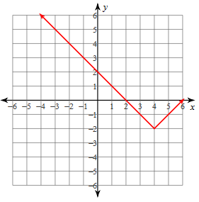
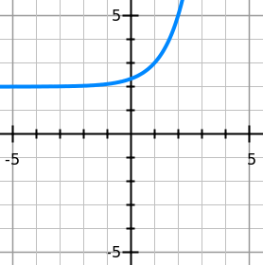

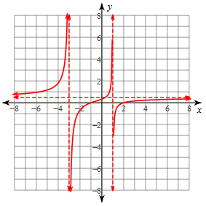
4. Are the following functions? Write yes or no.
a. b. $y^{2}=8xy+1$

c. $y=\sqrt{x+2}$

5. Find the local maximum and minimum, increasing and decreasing intervals, and domain and range for each of the following on the given interval.
a. $f\left(x\right)={-x}^{3}+{10x}^{2}-28x+19$
b. $f\left(x\right)=x^{4}-{3x}^{2}-2x+3$

6. Consider the graph of the polynomial function shown below.
a. What is the smallest possible degree for this polynomial function? Explain your reasoning.
b. Estimate the coordinates of all local maximum points.
c. Estimate the coordinates of all local minimum points.
d. Estimate the zeroes of this polynomial function.
7. Find the domain for each function. Show all of your work. Check your answer by graphing it on a calculator.
a. $f\left(x\right)=\frac{\sqrt{x+11}}{x^{2}+8x}$ b. $f\left(x\right)=\frac{x^{3}-1}{\sqrt{2x-3}}$

8. An open box is to be made from a rectangular piece of material, 8 cm by 10 cm, by cutting equal squares from the corners and turning up the sides. Let $x$ represent the length of the sides of the squares removed.
a. Write the volume, $V$, of the box as a function of $x$
b. Approximate the dimensions of the box that will yield a maximum volume
c. Find values of $x$ such that $V=48$. Which of these is a physical impossibility in the construction of the box?

9. Find the degree of the function, then sketch the graph (hint: find the multiplicity of each root!)
a. $y=-{\left(x-3\right)}^{3}(x+2){(x-5)}^{2}$ b. $y=x\left(x^{2}-4\right)\left(x^{2}+4x+4\right)$

10. Write the function for each graph.
a. b. c.
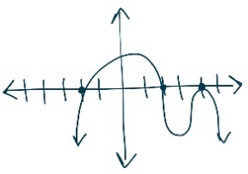
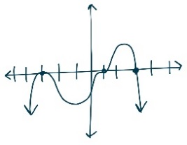
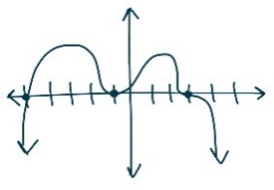

11. Find all real and complex roots for each polynomial function.
a. $f\left(x\right)=x^{5}-{11x}^{4}+{6x}^{3}+{102x}^{2}+9x+405$ b. $f\left(x\right)=x^{4}+{6x}^{3}+{9x}^{2}+14x-30$

12. Form a function with real coefficients that has a degree of 3 and roots of 2 with a multiplicity of 1 and $3-i$.

13. Graph the following piecewise functions.
a. b.
$f\left(x\right)=\left\{\begin{matrix}-x-4 if x<-2 \\ -\frac{1}{2}x if-2≤x≤2 \\ -1 if x>2\end{matrix}\right.$ $f\left(x\right)=\left\{\begin{matrix}x+4 if-6≤x<2 \\ -6 if x=2 \\ -x+2 if x>2\end{matrix}\right.$
14. Answer the following using the piecewise function from problem 13.
a. Find the domain of the function. b. Find the range of the function.
c. Find $f(-8)$ d. Find $f(0)$ e. Find $f(11)$
15. Solve the following inequalities.
a. $x+\frac{6}{x}≥5$ b. $\frac{x^{3}+{2x}^{2}-15x}{x^{2}-9}≤0$
16. Use the rational function $f\left(x\right)=\frac{-2x^{2}+2x+24}{x^{2}+3x}$ to find each of the following: VA, HA, Holes, Slant Asymptote, x- and y- intercept, and identify all possible limits
17. Consider the graph of the rational function $\left(x\right)=\frac{x^{2}-7x-8}{x^{2}-8x}$ .
a. Describe the domain of f(x) using set notation.
b. What are the coordinates of all x-intercepts of the graph?
c. Find equation(s) of all vertical asymptotes of f(x).
18. The number of bears in at any given time t, (in years) in a federal game reserve is given by $P\left(t\right)=\frac{500+250t}{10+0.5t}$
a. Find the population of bears when the value of t is 10.
b. According to the model, what is the largest bear population can become? Explain your answer.

2.05 Use polar equations to model and solve problems.
2.05a-Solve using graphs and algebraic properties (1)
2.05b-Interpret the constants and coefficients in the context of the problem (3)
Vocabulary/Concepts/Skills  Polar Coordinates  System  Pole  Radius  Magnitude  Direction  Argument  Translate between Rectangular & Polar Coordinates  Graphing Technology | 1. When recording live performances, sound engineers often use a cardioid microphone because it captures the singer’s voice with limited outside noise from the audience. Suppose the boundary of the optimal pickup region is given by the equation $r=2+2\sin{θ}$, where r is measured in meters from the microphone on the mic stand. What is the maximum distance a musician could stand away from the microphone and still be within this boundary?
2. Find the intersection of the following two polar graphs.
$r=2+3\sin{θ}$ and $r=\sin{θ}$

 | 3. Archaeologists want to create a map of a recent dig using polar coordinates. On their grid, they used a rectangular coordinate system and marked the king’s tomb at $\left(-12, 5\right).$ What would be the new coordinates of the king’s tomb if it were marked on a polar grid?
4. Convert the following equation from polar to rectangular form. $r=6\cos{θ}$

5. Convert the following equation from rectangular to polar form. $\frac{x^{2}}{25}+\frac{y^{2}}{16}=1$

6. Given the equations below:
- ${4x}^{2}+{8y}^{2}-8x+48y+44=0$
- $y^{2}-12x+18y+153=0$

- Identify the conic and write each equation in rectangular form.
- Write each equation in polar form.

7. Sketch the polar graphs:
a. $r=-3-3\cos{θ}$ b. $r=5\sin{3θ}$ c. $r=2+4\sin{θ}$

1.02 = 10% of total score points

1.02 Use the quadratic relations (quadratic, circle, ellipse, and hyperbola) to model and solve problems; justify results
1.02a-Solve using tables, graphs, and algebraic properties (2)
1.02b-Interpret the constants and coefficients in the context of the problem (1)
Vocabulary/Concepts/Skills  Parabola  Circle  Ellipse  Hyperbola  Conic Sections  Standard Form  Center  Focus  Major/Minor Axis  Vertices  Focal Axis  Lines of Symmetry  Directrix  Asymptotes  Transformations  Parametric Forms  Solve Equations/Inequalities & Justify Steps Used | 1. A parabolic satellite dish is modeled by the equation $y=\frac{1}{12}x^{2}$ and is measured in feet. In order to receive optimal signals, a satellite company must construct the receiver to be the focus of the parabolic dish.  How far from the vertex of the dish should the receiver be placed?
2. Given the following equation: $4y^{2}-2x-16y=-13-x^{2}$
a. Describe the type of conic section that is represented by the equation. Justify your response.
b. Sketch the graph that models the equation of the conic section.
3. A sonic boom is heard along a hyperbola. If you hear a sonic boom that is audible along a hyperbola with the equation $\frac{x^{2}}{100}-\frac{y^{2}}{4}=1$ where x and y are measured in miles.
What is the shortest horizontal distance you could be to the airplane?

4. The shape of a roller coaster loop in an amusement park can be modeled by
$\frac{y^{2}}{4225}+\frac{x^{2}}{2500}=1$ where x and y are measured in feet.
a. What is the width of the loop along the horizontal axis?
b. Determine the height of the roller coaster from the ground when it reaches the top of the loop, if the lower rail is 25 feet from ground level.

5. Use the given information to find an equation for each of the following.
a. An ellipse with vertices $\left(-6, 15\right) and (-6, -3)$ and foci $(-6, 6+3\sqrt{5}) and (-6, 6-3\sqrt{5})$.
b. A hyperbola with center $(-8, 4)$, a vertex at $(3, 4)$, and a focus at $(-8+\sqrt{146}, 4)$.

 | 6. Given ${(y-6)}^{2}=8(x+4)$, find the vertex, direction of opening, focus, and directrix.
 | 7. Given ${\left(x-6\right)}^{2}+{\left(y+2\right)}^{2}=10$, find the center and radius.
 | 8. Given $\frac{x^{2}}{16}+\frac{{(y-4)}^{2}}{9}=1$, find the center, vertices, co-vertices, foci, and major/minor axis.
 | 9. Given $\frac{x^{2}}{16}-\frac{{(y-4)}^{2}}{9}=1$, find the center, vertices, foci, and asymptotes
10. Classify the following conic sections. Then write the conic section in standard form.
a. $x^{2}+y^{2}+8x+11=0$ b. ${3y}^{2}+x+30y+73=0$

c ${25x}^{2}+{16y}^{2}+150x-32y-159=0$ d. ${-x}^{2}+{4y}^{2}+6x-16y+3=0$

  - + 1.03 = 7% of total score points

1.01 Transform relations in two dimensions, describe the results algebraically and geometrically. (1Q)
Vocabulary/Concepts/Skills  Effects of a, b, c, and d in $y=af\left(bx+c\right)d$  Coefficients  Translation  Reflection  Dilation  Even/Odd  Symmetries | 1. Let $f\left(x\right)= x^{2}-4x.$ Graph f (x) and g (x). Identify similarities and explain differences between f (x) and g (x).  a. $g\left(x\right)=2f\left(x\right)$ b. $g\left(x\right)=f\left(2x\right)$ c. $g\left(x\right)=-f\left(x\right)$  d. $g\left(x\right)=f\left(-x\right)$ e. $g\left(x\right)=f\left(x+2\right)$ f. $g\left(x\right)=f\left(x\right)-4$  g. $g\left(x\right)=|f\left(x\right)|$ h. $g\left(x\right)=f\left(|x|\right)$
2. If the graph of f (x) is given, sketch the graph of g (x). Use the transformations from Example 1a above.
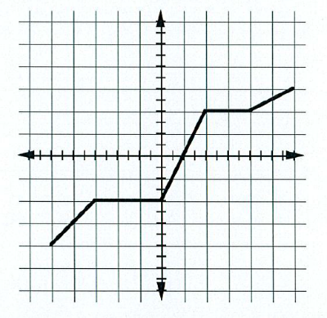
3. Describe the circle with equation $x^{2}+y^{2}-6x+4y-36=0$ in terms of a transformation of the unit circle whose center is at the origin.

4. Given $f\left(x\right)= \frac{1}{x}$ and $f (x+4)$.
- Graph the function and the transformation.
- Compare the domain, range, and asymptotes of the two functions.
- What are the domain, range, and asymptotes of $f^{-1}(x)$?

5. Classify the function. Write the transformations.
a. $y=-2{\left(x+11\right)}^{2}-4$9. b. $y=\frac{1}{2}\sqrt[3]{x-9}$

6. Write the equation of a cubic graph that has been reflected over the x-axis and shifted left 5 units.

7. Write the equation of a square root graph that has been vertically stretched by 5, moved up 6 units, and right 2 units.

8. Write the equation of a simple rational graph that has been translated left 3 units and down 8 units.

1.03 Operate with vectors in two dimensions to model and solve problems (1)
Vocabulary/Concepts/Skills  Magnitude  Direction  Addition/Subtraction of Vectors  Scalar Multiplication  Resultant Vector | 1. A pilot flies a plane due west for 150 miles, then turns 42° north of west for 70 miles. Find the plane’s resultant distance and direction from the starting point.
 | 2. A ferry shuttles people from one side of a river to the other. The speed of the ferry in still water is 25 mi/h. The river flows directly north at 9 mi/h. If the ferry heads directly west, what are the ferry's resultant speed and direction?
 | 3. To find the distance between two points A and B on opposite sides of a lake, a surveyor chooses a point C which is 720 feet from A and 190 feet from B. If the angle at C measures 68°, find the distance from A to B.
 | 4. Miss Wright is flying an airplane. The airplane has an airspeed of 350 kilometers per hour in the direction $S20°W$. The wind velocity is 42 kilometers per hour in the direction $S10°E$. Find the resultant vector representing the path of the plane relative to the ground. What is the ground speed of the plane? What is its direction?
5. A vector v had an initial point P and a terminal point Q. Find its position vector and write it in both component and $ai+bj$ form.
a. $P=(-11, 4)$ and $Q=(3, -8)$ b. $P=\left(0, 13\right)$ and $Q=(7, -1)$

6. Use the vectors to answer the following questions.
$v=-3i+8j$ $w=6i-4j$ $z=7j$
a. $4v-w$ b. $3w+7z$
c. $\left\|v\right\|+\left\|w\right\|$ d. $\left\|v+w\right\|$
e. $v∙w$ f. $v∙z$
g. unit vector for v h. angle between v and w

2.03 + 2.06 = 7% of total score points
2.03 For sets of data, create and us calculator-generated models of linear, polynomials, exponential, trigonometric, power, logistic, and logarithmic function.
2.03a Interpret the constants, coefficients, and bases in the context of the data (0)
2.03b Check models of goodness-of-fit; use the most appropriate model to draw conclusions or make predictions (1)
Vocabulary/Concepts/Skill  Regression  Residuals  Correlation Coefficient  Interpret constants, coefficients, bases  Interpolate  Extrapolate  Estimate  Predict | 1. The data in the table shows the circulation in millions of USA Today from 1985 to 1993. Years are shown as the number of years since 1985.  Years since 1985 0 1 2 3 4 5 6 7 8  Circulation 1.418 1.459 1.586 1.656 1.755 1.843 1.867 1.957 2.001  Number of Years Since 1970 Number of Subscribers (millions)  0 4.5  5 9.8  10 16.0  14 29.0  16 37.5  18 44.0  20 50.0  22 53.0  24 55.3  a. Use the first and last data points to find an exponential model of the form $y = ae^{bx}$ for the data. How good is the fit?  b. According to this model, what  is the estimated circulation in 2002?  c. Compare the estimate with the actual circulation. What other functions might model the data well?  e. Explain why another function is more reasonable in the context of the problem.
2. Shown is the number of cable television subscribers in the US for several years between 1970 and 1994. Years are expressed as number of years since 1970 and the number of subscriptions is given in millions.
- Look at a scatter plot of the data and decide on an appropriate function to model the data.
- The data appears to be leveling off. What in the context explains the leveling off?
- Looking at your equation model, what is the number to which the data levels off- i.e. what is the carrying capacity?

2.06 Use parametric equations to model and solve problems (1)
Vocabulary/Concepts/Skills  Parameter  Dependent/Independent Variable  Parametric Plots  Motion over time  Translate between parametric and rectangular form | 1. Two rockets are fired from a space station. The first rocket’s path can be described using the parametric equations $x\left(t\right)=t+4$ and $y\left(t\right)=3t-1$. The second rocket’s path can  be described using the parametric equations $x\left(t\right)=t+4$ and $y\left(t\right)=2t+9$.  a. Eliminate the parameter for the equations given for the first rocket and express its path as a function.  b. Eliminate the parameter for the equations given for the second rocket and express its  path as a function.  c. Will the two rockets collide? Defend your answer using mathematical reasoning
2. Eliminate the parameter of the following parametric equations.
a. $x=t+2, y=t^{2}-7 for 0≤t≤4$

